
BRAF (V600A)
Catalog Number: CR-M 26199
Gene Symbol: BRAF, BRAF1, RAFB1
Description: Anti-BRAF (V600A) Mouse Monoclonal Antibody

Background: BRAF belongs to a family of
serine-threonine protein kinases. As a part of a
signaling pathway known as the the RAS/MAPK pathway, it plays an important part in many
cellular processes. The processes include cell
proliferation, differentiation and transcriptional regulation. Mutations in the BRAF gene cause diseases. Inherited mutations in BRAF cause
cardiofaciocutaneous syndrome. Acquired
mutations in BRAF have been found in cancers. Immunogen: A synthetic peptide from the
internal region of BRAF which includes the mutation of V600A, human origin.
Tested applications: ELISA, WB, IF, IHC Recommended dilutions:
ELISA: 1:1000-1:5000
WB: 1:500-1:1000
IF: 1:50-1:100
IHC: 1:25-1:100
Concentration: 1 mg/ml
Host: Mouse
Clonality: Monoclonal
Purity: Purified from ascites
Format: Liquid Storage buffer:
Preservative: no
Constituents: PBS (without Mg2+ and Ca2+), pH 7.4, 150 mM NaCl, 50% glycerol
Species Reactivity: Recognizes V600A mutant, but not wild-type BRAF of vertebrates.
Storage Conditions: Store at -20°C. Avoid freeze / thaw cycles.

Western blot:
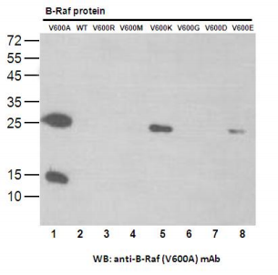
Western blot analysis of recombinant BRAF proteins. Purified His-tagged BRAF (V600A)
protein (lane 1) , corresponding wildtype protein (lane 2) , His-tagged BRAF (V600R) protein
(lane 3), His-tagged BRAF (V600M) protein
(lane 4), His-tagged BRAF (V600K) protein
(lane 5), His-tagged BRAF (V600G) protein
(lane 6), His-tagged BRAF (V600D) protein
(lane 7) and His-tagged BRAF (V600E) protein (lane 8) were blotted with anti-BRAF (V600A) monoclonal antibody (Cat. #26199).

For research use only. Not for diagnostic or therapeutic applications.

科博瑞（武汉）生物科技有限公司
TEL：027-87615885 15972062685
- mail：3636901710@qq.com
Web:www.coburybio.com
Immunofluorescence:
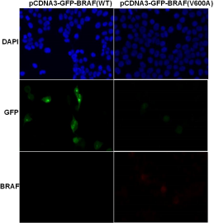

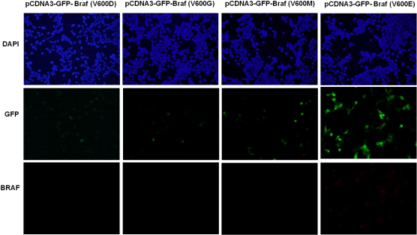
Immunofluorescence of cells expressing BRAF proteins with anti-BRAF (V600A) antibody. HEK293T cells were transfected with
pCDNA3-GFP-BRAF (WT) plasmid, pCDNA3-GFP-BRAF (V600A) plasmid,
pCDNA3-GFP-BRAF (V600D) plasmid, pCDNA3-GFP-BRAF (V600G) plasmid
pCDNA3-GFP-BRAF (V600M) plasmid or pCDNA3-GFP-BRAF (V600E) plasmid, then fixed and stained with anti-BRAF (V600A) monoclonal antibody (Cat. #26199).

